

**Certificate of Attendance**

**This is to certify that**

**Attended the**

**BSPGHAN Zoom Education Talk**

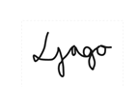

**Dr Loveday Jago**

**Chair BSPGHAN Education Group**