

**Certificate of Attendance**

**This is to certify that**

**Attended the PeGHAN Virtual Study Day**

**7th March 2022**

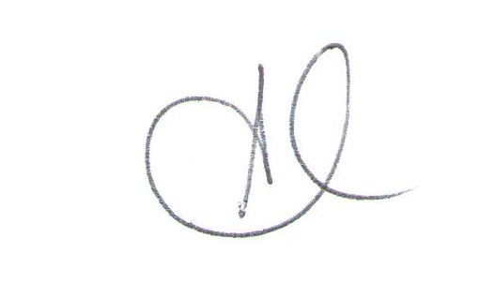

**Dr Shveta Chana**

**Chair of BSPGHAN Paediatricians with an Interest in Gastroenterology, Hepatology and Nutrition Group**

**RCPCH has approved this activity for CPD in accordance with current RCPCH CPD guidelines**