Antibiotic lock solutions prevent CRBSI – a systematic review

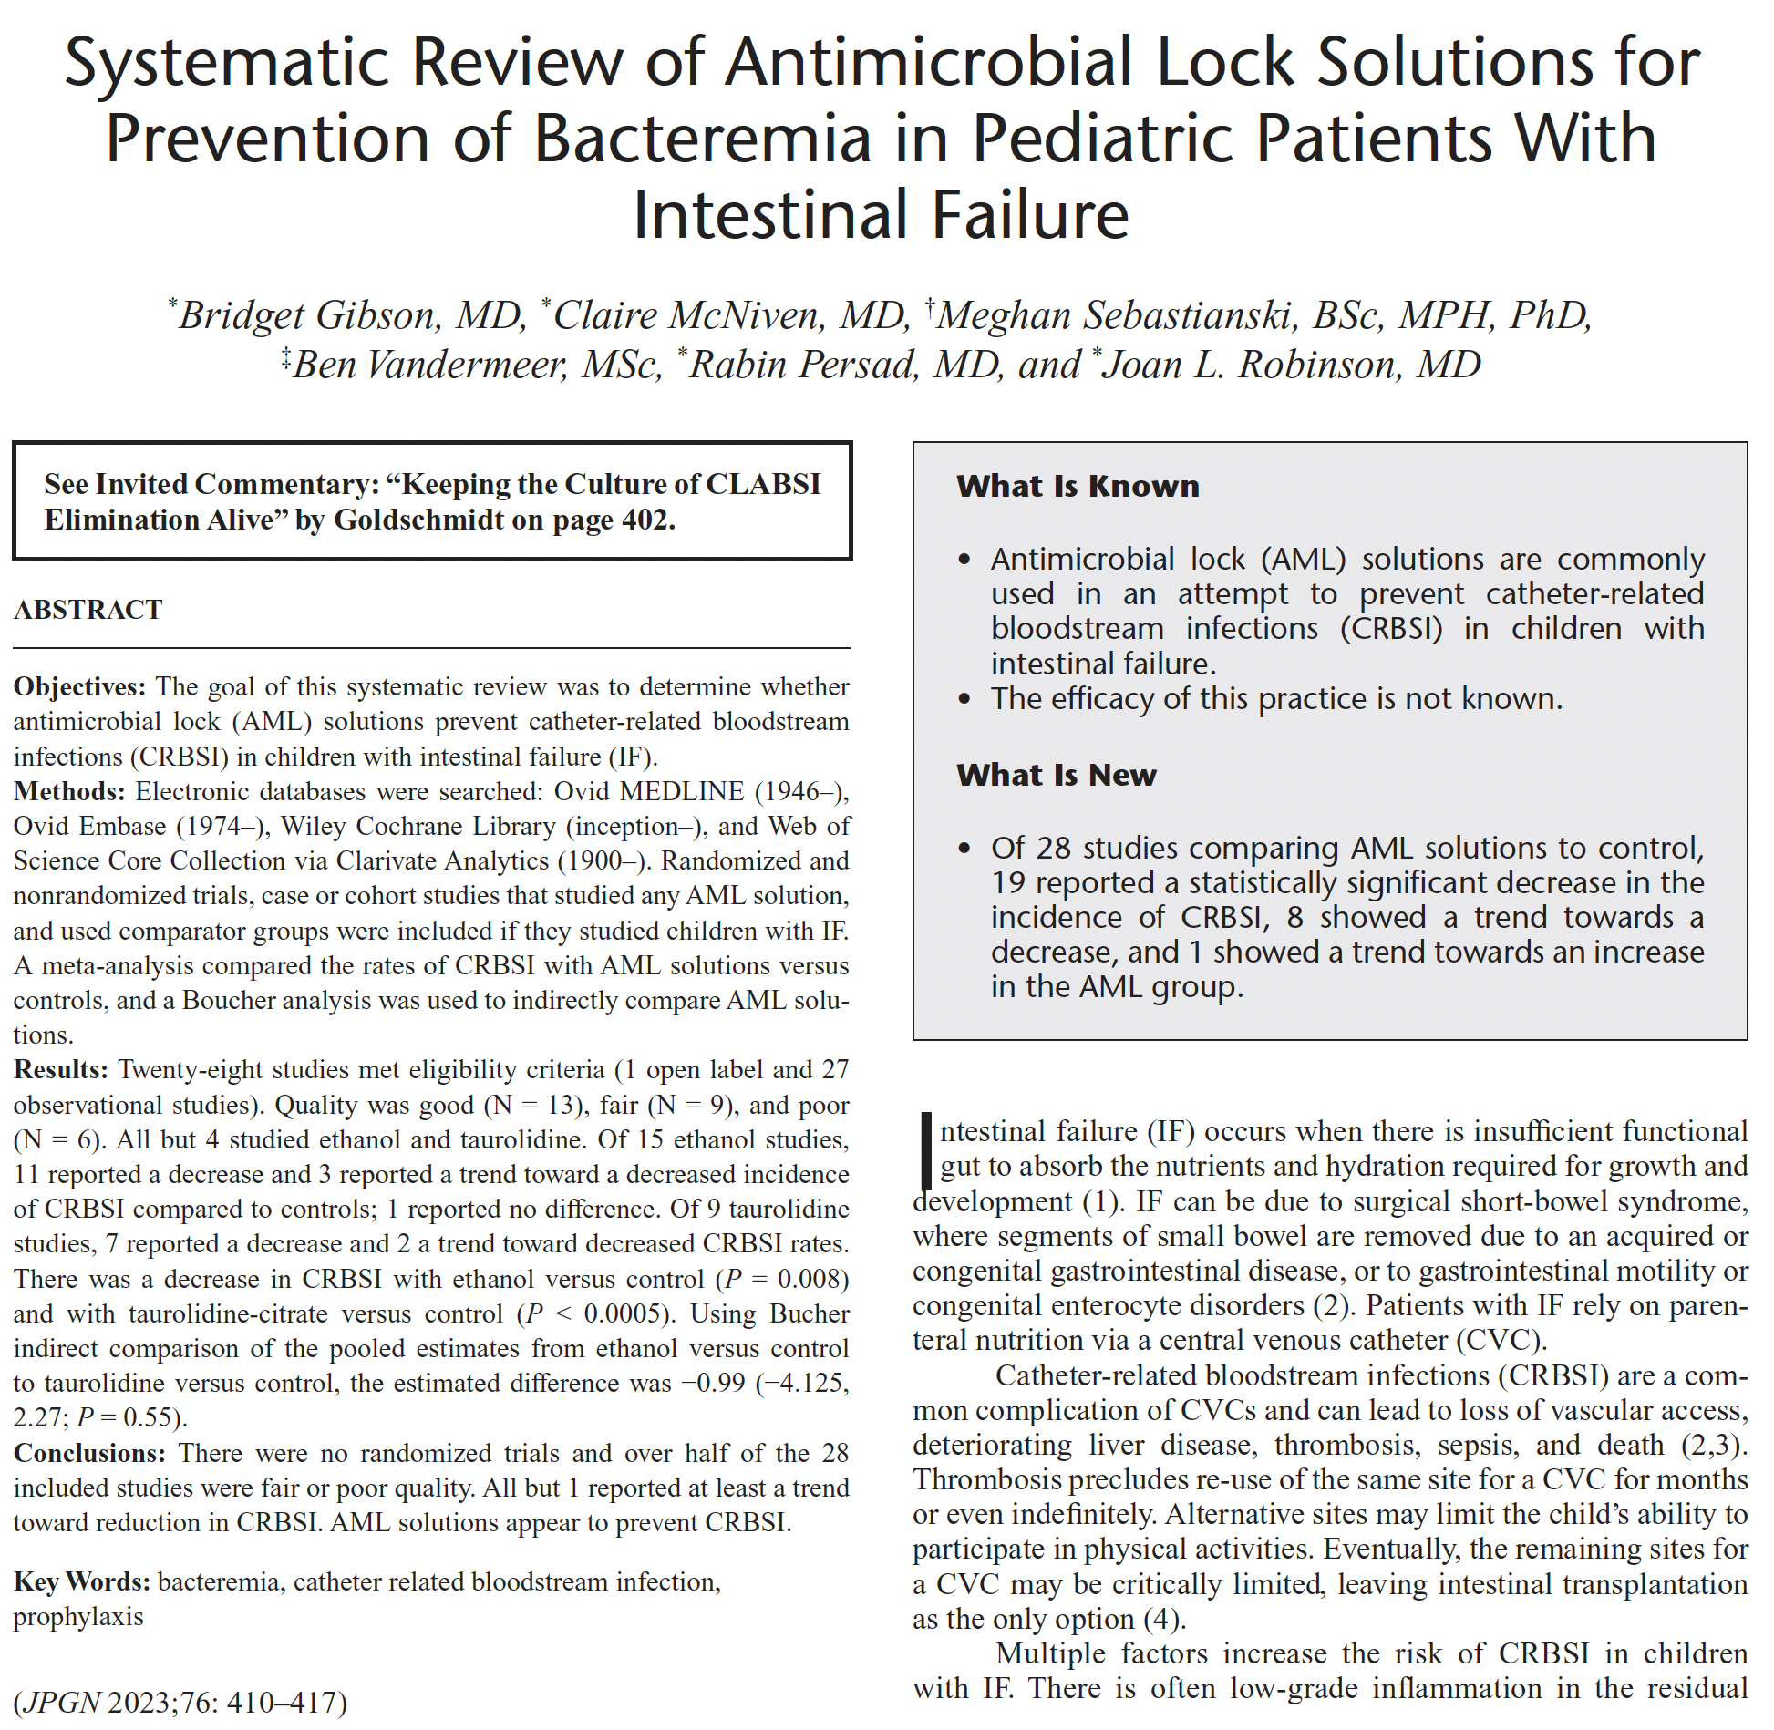

Full text link

