Diagnostic yield of routine biopsies in Paediatric Gastrointestinal Endoscopy

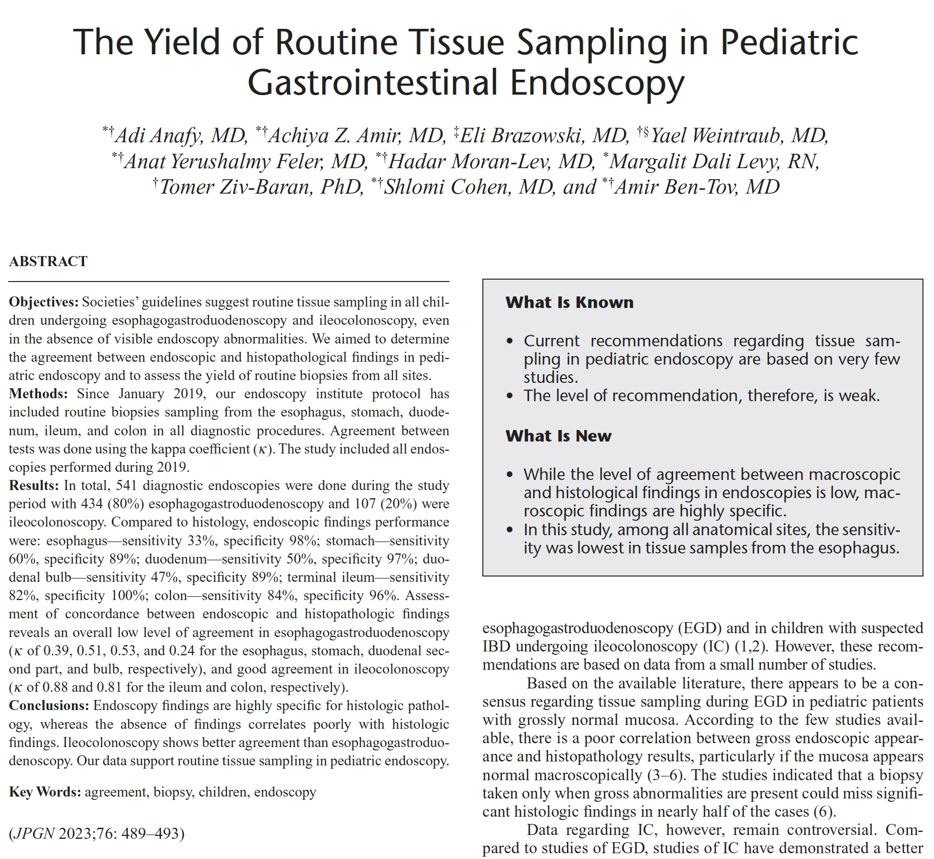

Full text link

