Dupilumab, A monoclonal antibody for the treatment of eosinophilic oesophagitis

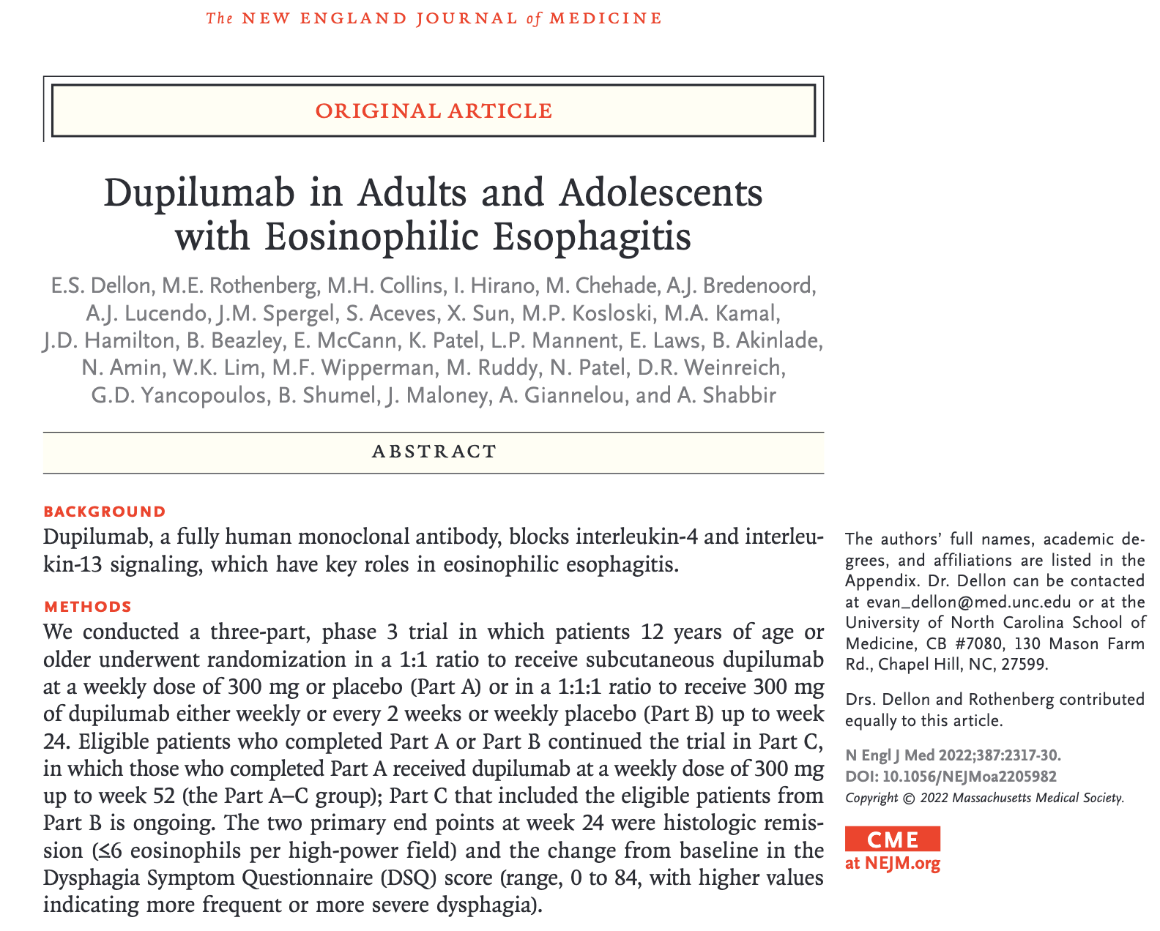

https://www.nejm.org/doi/10.1056/NEJMoa2205982

