Efficacy and Safety of Drugs for Gastroparesis: Systematic Review

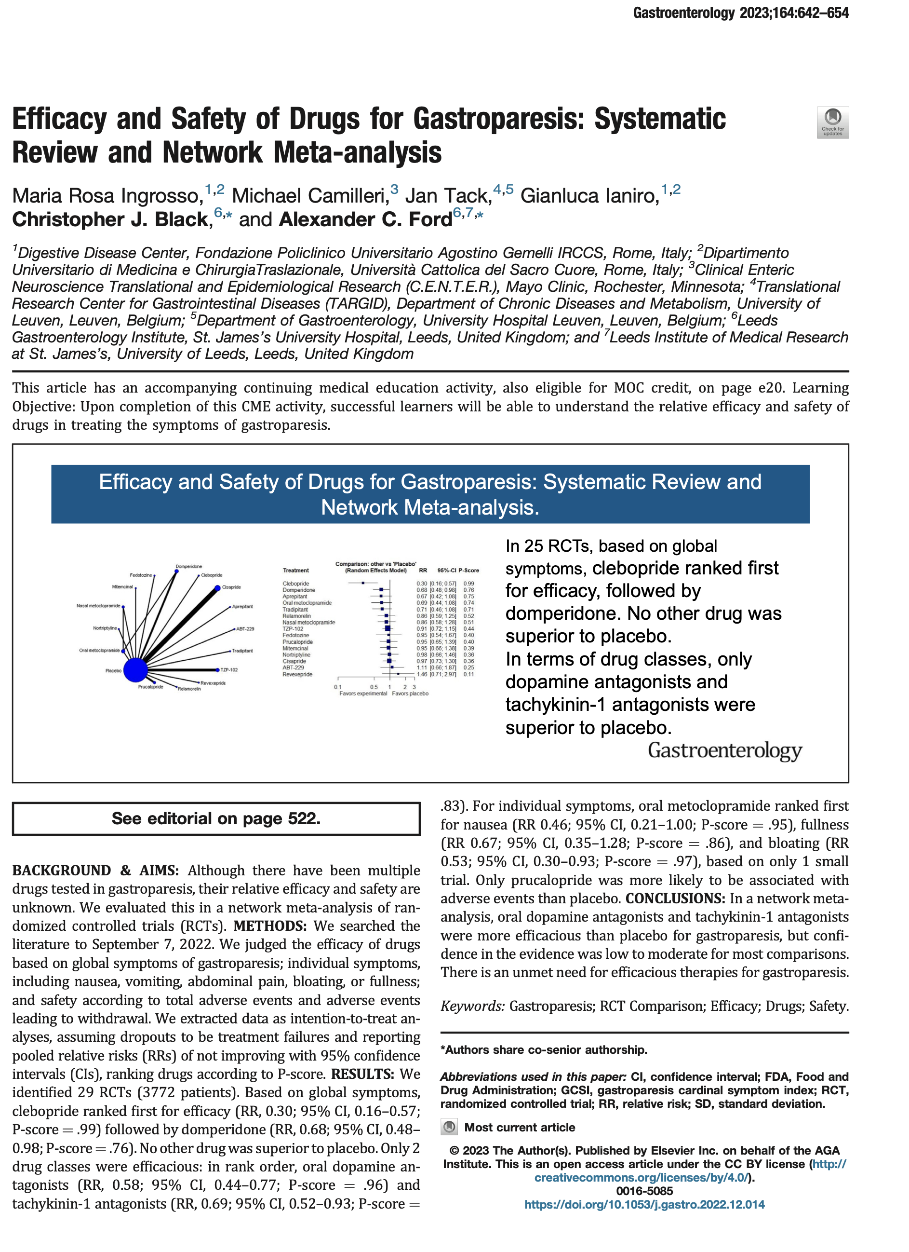

https://doi.org/10.1053/j.gastro.2022.12.014

