Exocrine pancreatic dysfunction in IBD

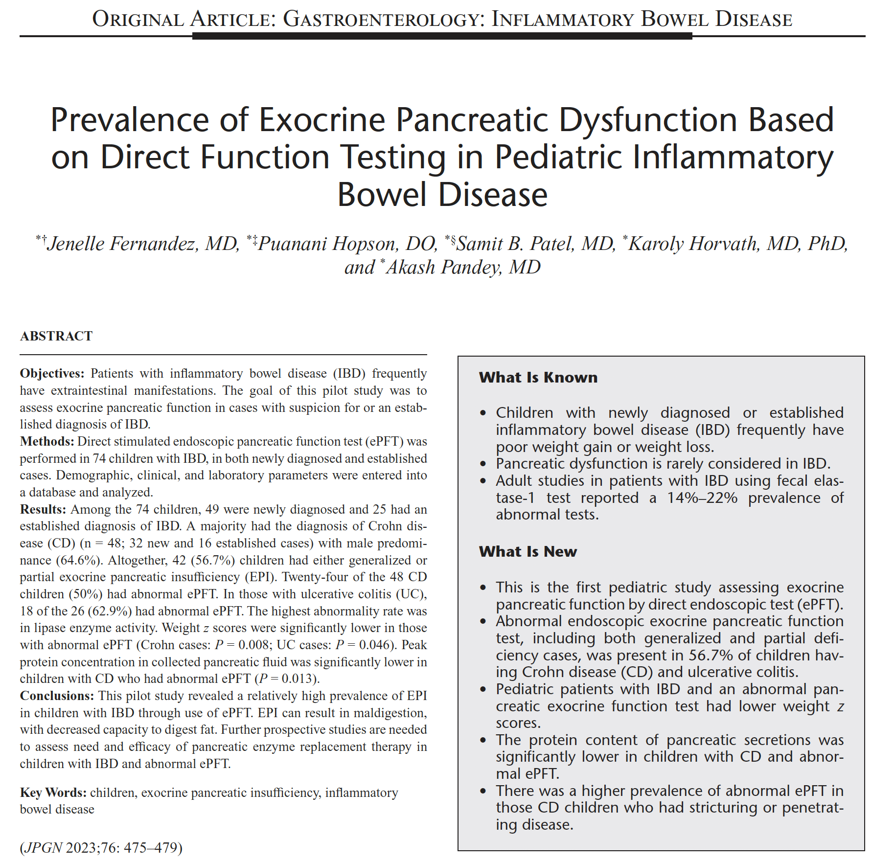

Full text link

