Gastrointestinal Endoscopy post HSCT

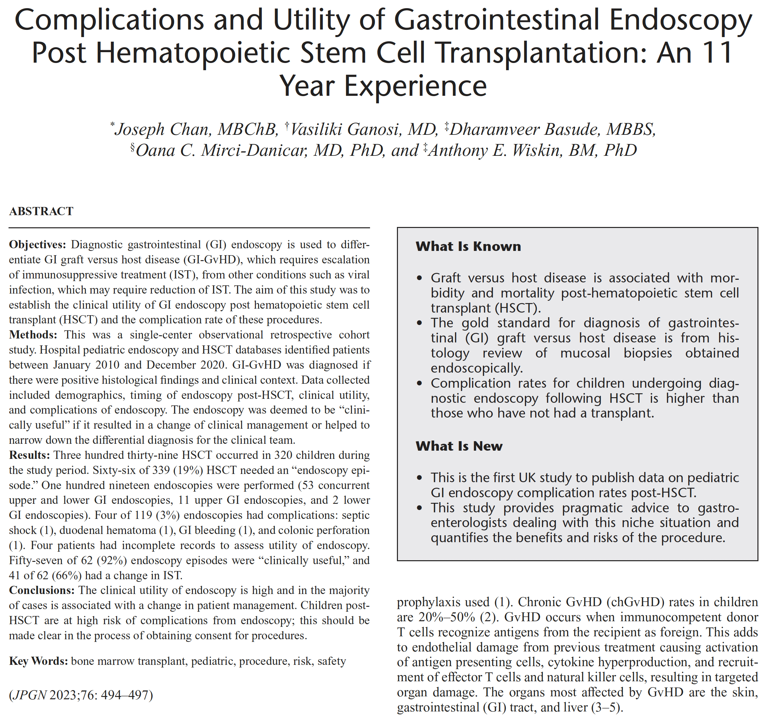

Full text link

