Pathogenic TRPV6 variants increase the risk of recurrent acute pancreatitis or chronic pancreatitis in children

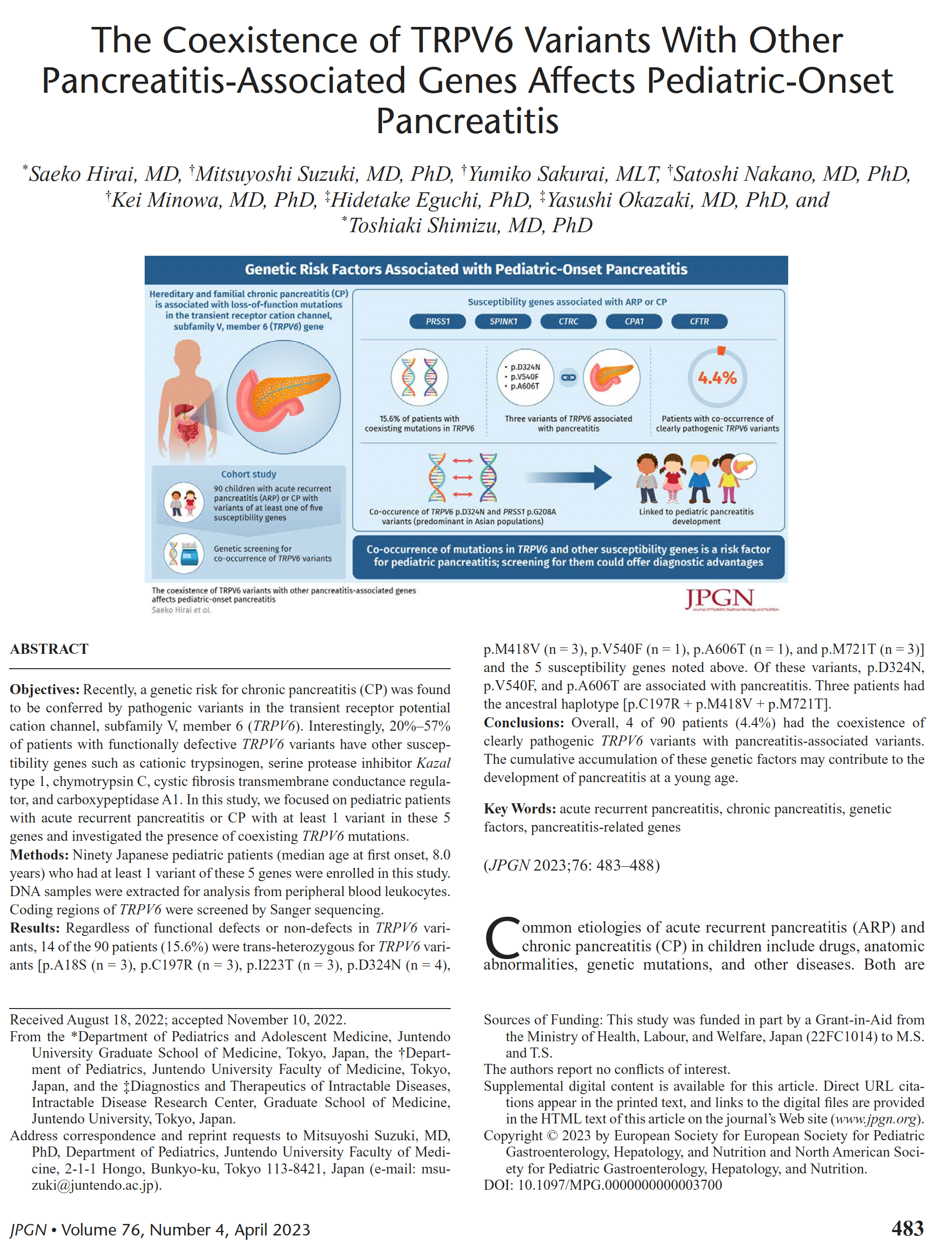

Full text link

