Treatment of Rumination syndrome in children.
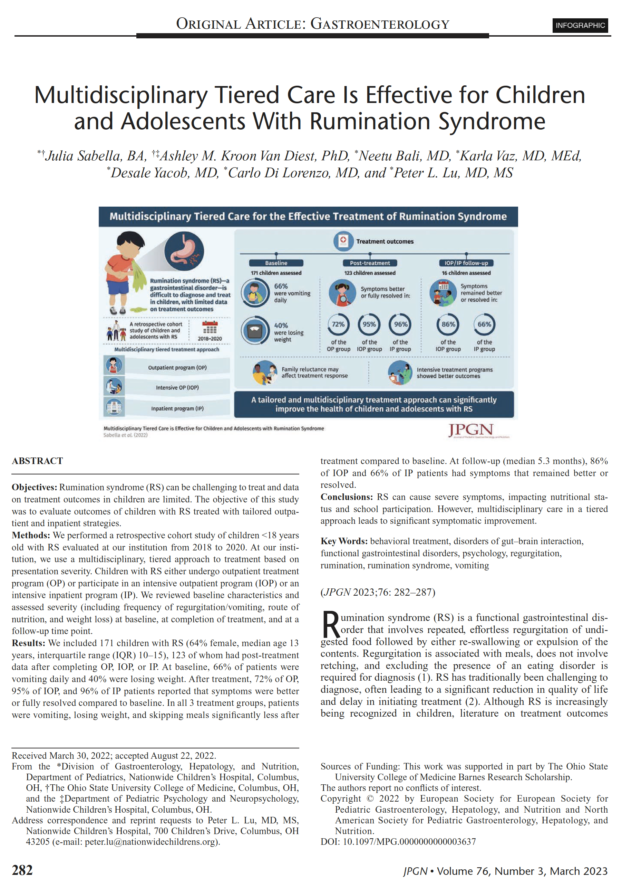Full text

