Link: Acute pancreatitis in children with inflammatory bowel disease: Risk factors, clinical course, and prognosis - Anafy - Journal of Pediatric Gastroenterology and Nutrition - Wiley Online Library

Journal of Pediatric Gastroenterology and Nutrition
ORIGINAL ARTICLE
Acute pancreatitis in children with inflammatory bowel disease: Risk factors, clinical course, and prognosis
Adi Anafy, Yehoshua Mirkin, Tut Galai, Amir Ben-Tov, Hadar Moran-Lev, Anat Yerushalmy-Feler, Shlomi Cohen, Achiya Z. Amir
First published: 05 June 2024

https://doi.org/10.1002/jpn3.12279
[Correction added on 20 June 2024, after first online publication: The name of the fifth author has been corrected.]
Read the full text
PDF
TOOLS

SHARE
Abstract
Objectives
To characterize the clinical course of acute pancreatitis (AP) in pediatric inflammatory bowel disease (IBD) patients compared to children with AP without IBD and to identify risk factors associated with AP among IBD patients.
Methods
This retrospective, single-center study compared clinical characteristics of children (<19 years) with AP with and without concomitant IBD who were hospitalized 2005–2019. We also conducted a risk factor analysis of AP development in pediatric IBD.
Results
Sixty-eight (54% males) patients with 120 episodes of AP were admitted at a median age of 15.3 years. Thirteen patients (14 episodes) had a co-diagnosis of IBD, representing 4% of our IBD patient population. The AP-IBD patients presented with lower amylase levels compared to the non-IBD patients (160 [interquartile range, IQR: 83–231] vs. 418 [IQR: 176–874] U/L, p > 0.01), all had a mild pancreatitis, and none required invasive intervention. The presumed etiology for AP in all IBD patients was IBD-related: IBD flare-up in five, side effects of medications in two, and undetermined in seven. The only risk factor for AP development among IBD patients was IBD-associated arthritis (23% vs. 3% for IBD-non-AP, p = 0.04), while extracolonic Crohn's disease and induction therapy with nutrition were negative risk factors (15% vs. 51%, p = 0.05, and 8% vs. 44%, p = 0.04, respectively). Other parameters, including disease type and medications, were nonsignificant.
Conclusion
The clinical course of AP in pediatric IBD patients is mild. Only IBD-associated arthritis emerged as a risk factor for the development of AP, while, unexpectedly, IBD medication did not.
Graphical Abstract
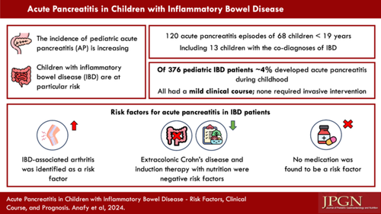
CONFLICT OF INTEREST STATEMENT

