Link: Goodbye, NAFLD, hello, MASLD?! - Mouzaki - Journal of Pediatric Gastroenterology and Nutrition - Wiley Online Library

EXPERIENCE FROM THE FIELD
Goodbye, NAFLD, hello, MASLD?!
Marialena Mouzaki, Alexandria Speakman, Stavra Xanthakos
First published: 04 June 2024

https://doi.org/10.1002/jpn3.12247
Topic of the Month (Clinical Care)
PDF
TOOLS

SHARE
Get access to the full version of this article.View access options below.
Institutional Login

Access through your institution

Log in to Wiley Online Library
If you have previously obtained access with your personal account, please log in.
Log in with CONNECT

One account for all your research.Wiley Online Library is part of the CONNECT Network.
Purchase Instant Access
48-Hour online access$12.00
- Details
Online-only access$20.00
- Details
PDF download and online access$49.00
- Details
Check out
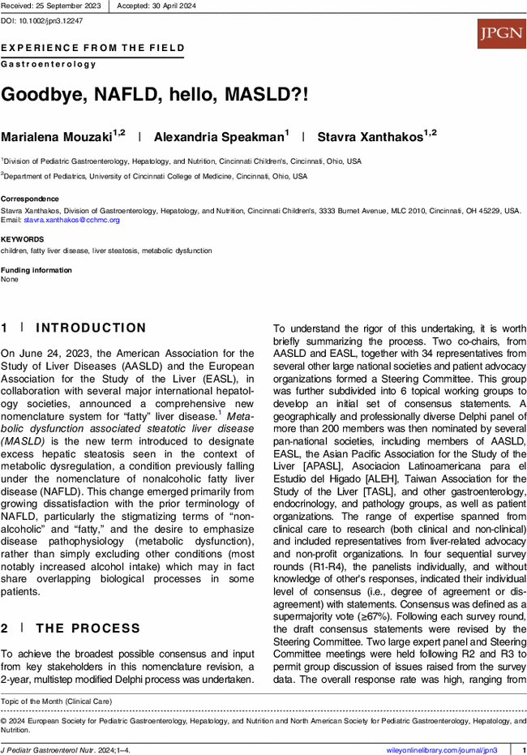
CONFLICT OF INTEREST STATEMENT
SAX and MM have received restricted research funding from TargetRWE.
REFERENCES

