Link: Performance of Baveno VII criteria for the screening of varices needing treatment in patients with biliary atresia - Ling - Journal of Pediatric Gastroenterology and Nutrition - Wiley Online Library

Journal of Pediatric Gastroenterology and Nutrition
ORIGINAL ARTICLE
Performance of Baveno VII criteria for the screening of varices needing treatment in patients with biliary atresia
Yu-Chieh Ling, Chien-Ting Hsu, Cheng-Yu Chen, Chi-San Tai, Kai-Chi Chang, Jia-Feng Wu
First published: 03 June 2024

https://doi.org/10.1002/jpn3.12278
Read the full text
PDF
TOOLS

SHARE
Abstract
Objective
Biliary atresia (BA) is the leading cause of liver cirrhosis and chronic liver insufficiency in children in the world. Gastroesophageal varices bleeding is an ominous complication of cirrhosis in BA patients and is associated with high morbidity and mortality. In this study, we aimed to investigate the utility of noninvasive Baveno VI and Baveno VII criteria for the screening of varices need treatment (VNT) and the need for liver transplantation in BA patients.
Methods
This study enrolled 48 BA patients (23 females and 25 males) who underwent an esophagogastroduodenoscopy (EGD) and transient elastography at a mean age of 11.18 ± 1.48 years; the clinical data were surveyed in a retrospective design.
Results
The sensitivity and negative predictive value of Baveno VI and Baveno VII criteria for the prediction of VNT in BA patients are both 100% and 100%, respectively. The VNT missing rate of Baveno VI and Baveno VII criteria are both 0% in our cohort. The Baveno VI, expanded Baveno VI, and Baveno VII criteria are also predictive of the need for liver transplantation in our cohort (OR = 10.33, 4.24, and 21.33; p = 0.009, 0.03, and 0.007, respectively).
Conclusion
The Baveno VI and Baveno VII criteria are useful for the screening of VNT and minimize non-necessary invasive EGD in BA patients with low VNT missing rates. The Baveno VI, expanded Baveno VI, and Baveno VII criteria are associated with the need for liver transplantation.
Graphical Abstract
Non-invasive Baveno criteria for BA patients
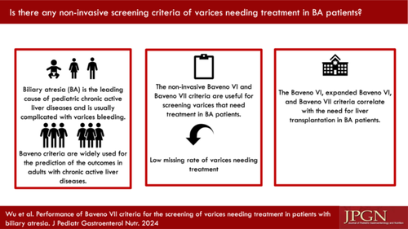
CONFLICT OF INTEREST STATEMENT

