Link: <https://onlinelibrary.wiley.com/doi/10.1002/jpn3.70138>

[](https://onlinelibrary.wiley.com/journal/15364801)

ORIGINAL ARTICLE

**Development and validation of a simple nomogram for predicting severe acute pancreatitis in children**

[Cai-Xia Feng](https://onlinelibrary.wiley.com/authored-by/Feng/Cai%E2%80%90Xia), [Wen-Yu Ye](https://onlinelibrary.wiley.com/authored-by/Ye/Wen%E2%80%90Yu), [Lian-Cheng Lan](https://onlinelibrary.wiley.com/authored-by/Lan/Lian%E2%80%90Cheng), [Si-Xing Chen](https://onlinelibrary.wiley.com/authored-by/Chen/Si%E2%80%90Xing), [Xiu-Qi Chen](https://onlinelibrary.wiley.com/authored-by/Chen/Xiu%E2%80%90Qi), [Qing Tang](https://onlinelibrary.wiley.com/authored-by/Tang/Qing), [Li Huang](https://onlinelibrary.wiley.com/authored-by/Huang/Li), [Xiao-Yin He](https://onlinelibrary.wiley.com/authored-by/He/Xiao%E2%80%90Yin), [Shu-Heng Liang](https://onlinelibrary.wiley.com/authored-by/Liang/Shu%E2%80%90Heng), [Yun Li](https://onlinelibrary.wiley.com/authored-by/Li/Yun), [Yi Wu](https://onlinelibrary.wiley.com/authored-by/Wu/Yi), [Juan Li](https://onlinelibrary.wiley.com/authored-by/Li/Juan), [Qing-Wen Shan](https://onlinelibrary.wiley.com/authored-by/Shan/Qing%E2%80%90Wen)

First published: 07 July 2025

[**https://doi.org/10.1002/jpn3.70138**](https://doi.org/10.1002/jpn3.70138)

Cai-Xia Feng and Wen-Yu Ye are co-first authors.

[**Read the full text**](https://onlinelibrary.wiley.com/doi/full/10.1002/jpn3.70138)

**Abstract**

Objective

To develop and validate a nomogram for predicting severe acute pancreatitis (SAP) in children, aiding early identification and intervention of this potentially fatal condition.

Methods

This study employed a retrospective dual-center design, involving two large tertiary children's hospitals. All pediatric patients under the age of 18 years diagnosed with acute pancreatitis (AP) were included. The primary predicted outcome was the probability of children with AP progressing to SAP. We used the Least Absolute Shrinkage and Selection Operator (LASSO) regression to select optimal predictors and logistic regression to build a nomogram. The model's performance was evaluated using ROC curves, a Calibration Curve, and Decision Curve Analysis (DCA). Internal and external validations were performed.

Results

For the training cohort, we enrolled 152 pediatric AP episodes, among which 23 episodes (15.1%) were categorized as SAP. In the external validation cohort, we included 60 pediatric AP episodes, with 7 episodes (11.7%) being classified as SAP. The nomogram, based on fever, C-reactive protein, blood urea nitrogen, albumin, and calcium, showed good performance with an AUC of 0.875, sensitivity of 0.913, specificity of 0.76 in the training cohort and an AUC of 0.97, sensitivity of 0.857, specificity of 1 in the external validation cohort. Excellent calibration as evidenced by the Hosmer-Lemeshow test (*p* > 0.05) and the Calibration Curve, and high clinical utility as shown by the Clinical Decision Curve.

Conclusions

Our research created and validated a simple nomogram for predicting SAP in children, enabling early risk stratification and guiding effective interventions.

**Graphical Abstract**

[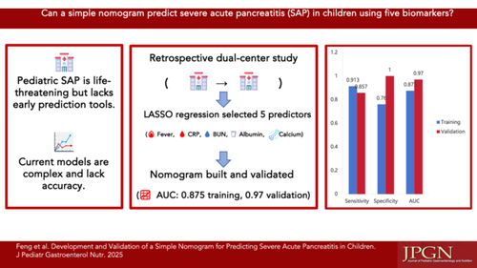](https://onlinelibrary.wiley.com/cms/asset/42235f15-8339-47c5-b428-de84f7b30559/jpn370138-gra-0001-m.jpg)

**CONFLICT OF INTEREST STATEMENT**

All authors declare no conflicts of interest.