Link: <https://onlinelibrary.wiley.com/doi/10.1002/jpn3.70169>

[](https://onlinelibrary.wiley.com/journal/15364801)

ORIGINAL ARTICLE

**Enhancing food insecurity screening in pediatric celiac disease using a quality improvement framework**

[Telly Cheung](https://onlinelibrary.wiley.com/authored-by/Cheung/Telly), [Mala Setty](https://onlinelibrary.wiley.com/authored-by/Setty/Mala), [Erica Riray](https://onlinelibrary.wiley.com/authored-by/Riray/Erica), [Bradley Green](https://onlinelibrary.wiley.com/authored-by/Green/Bradley), [Sharad I. Wadhwani](https://onlinelibrary.wiley.com/authored-by/Wadhwani/Sharad+I.), [Namrata Patel-Sanchez](https://onlinelibrary.wiley.com/authored-by/Patel%E2%80%90Sanchez/Namrata)

First published: 21 July 2025

[**https://doi.org/10.1002/jpn3.70169**](https://doi.org/10.1002/jpn3.70169)

[**Read the full text**](https://onlinelibrary.wiley.com/doi/full/10.1002/jpn3.70169)

**Abstract**

Objectives

Food insecurity (FI) affects more than 18 million households in the United States. Children with celiac disease (CeD) depend exclusively on the gluten-free diet, yet gaps persist in screening for food-insecure households who could benefit from interventions. We developed a system to identify and address barriers to FI screening in a pediatric clinic for CeD.

Methods

Using the Model for Improvement, we conducted quality initiatives for eligible households between January 1, 2024 and January 31, 2025. We surveyed the medical team to identify barriers to FI screening and designed a key driver diagram to inform plan-do-study-act cycles. We implemented a (1) validated screening form, (2) clinic flowsheet, (3) educational module, and (4) visual aid in the electronic health records. We measured the process of FI screening and documentation. We tracked outcomes on positive screens for general and gluten-free FI.

Results

Among 100 eligible children, the majority were female (63.0%), other race (55.0%), non-Hispanic (66.0%), and primary English-speakers (80.0%); and 66 received FI screening (66.0%). We identified top team-reported barriers to FI screening: language barriers, lack of FI resources, forgetting, and discomfort with asking questions. Applying the model for Improvement, we improved median FI screening from 0.0% to ≥75.0% within 12 months and sustained screening rates for ≥6 months. The average general and gluten-free FI among screened households was 19.7% and 14.8%, respectively.

Conclusions

We implemented a systematic framework to address team-reported barriers, helping to increase FI screening for children with CeD. Developing interventions to address FI may improve poor outcomes among food-insecure households.

**Graphical Abstract**

[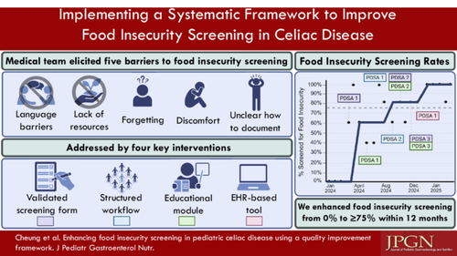](https://onlinelibrary.wiley.com/cms/asset/562b3239-ddea-434d-afac-754c07d85ab5/jpn370169-gra-0001-m.jpg)

**CONFLICT OF INTEREST STATEMENT**

Sharad I. Wadhwani served on the Medical Advisory Board for Mirum Pharmaceuticals. The NIH/NIDDK Training Grants T32-DK007762 (Telly Cheung) and K23-DK132454 (Sharad I. Wadhwani) supported this study. The remaining authors declare no conflicts of interest.