Link: <https://onlinelibrary.wiley.com/doi/10.1002/jpn3.70161>

[](https://onlinelibrary.wiley.com/journal/15364801)

ORIGINAL ARTICLE

**Nutrition practices of children with pediatric intestinal pseudo-obstruction in Europe—A survey by the network for intestinal failure rehabilitation and transplantation in Europe**

[Alessandra Mari](https://onlinelibrary.wiley.com/authored-by/Mari/Alessandra), [Keith James Lindley](https://onlinelibrary.wiley.com/authored-by/Lindley/Keith+James), [Anat Guz-Mark](https://onlinelibrary.wiley.com/authored-by/Guz%E2%80%90Mark/Anat), [Johannes Hilberath](https://onlinelibrary.wiley.com/authored-by/Hilberath/Johannes), [Iva Hojsak](https://onlinelibrary.wiley.com/authored-by/Hojsak/Iva), [Lorenzo Norsa](https://onlinelibrary.wiley.com/authored-by/Norsa/Lorenzo), [Merit Tabbers](https://onlinelibrary.wiley.com/authored-by/Tabbers/Merit), [Rut Anne Thomassen](https://onlinelibrary.wiley.com/authored-by/Thomassen/Rut+Anne), [Elvira Verduci](https://onlinelibrary.wiley.com/authored-by/Verduci/Elvira), [Jutta Kӧglmeier](https://onlinelibrary.wiley.com/authored-by/K%D3%A7glmeier/Jutta)

First published: 21 July 2025

[**https://doi.org/10.1002/jpn3.70161**](https://doi.org/10.1002/jpn3.70161)

[**Read the full text**](https://onlinelibrary.wiley.com/doi/full/10.1002/jpn3.70161)

**Abstract**

Objectives

Pediatric intestinal pseudo-obstruction (PIPO) is the most severe disorder of gut motility in childhood. Consensus on how and if patients should be fed (solid or bite and dissolve oral diet, gastric, jejunal, or parenteral feeding) is lacking. Our aim was to investigate the current nutrition practices among European referral centers, to aid in developing a future evidence-based consensus guideline.

Methods

An electronic questionnaire was circulated via the Network of Intestinal Failure Rehabilitation and Transplantation in Europe. Data collected between October 2023 and March 2024 included patient demographics, disease phenotype based on the European Society for Paediatric Gastroenterology, Hepatology and Nutrition PIPO criteria, and type of feeding.

Results

Data from 84 patients from 9 centers (8 European and 1 Israeli) were received. A total of 73 children fulfilled PIPO criteria and were included; 48 (65.8%) females, 55 (75%) became symptomatic within the first year of life; 9 (12.3%) ate a normal solid diet, 64 (87.7%) required permanent nutrition support; 2 (2.7%) were on exclusive tube enteral nutrition (EN), 9 (12.3%) on exclusive parenteral nutrition (PN), 53 (72.6%) on a combination of PN and oral diet (normal/bite and dissolve/normal but minimal intake) and/or EN. Use of exclusive PN is more common in adolescents compared to younger children. 19 (26%) eventually re-established enteral/oral intake: 8 (42.1%) after stoma formation, 7 (36%) following prokinetic induction, 1 (5.2%) after intestinal transplantation.

Conclusions

Nutrition practices in children with PIPO vary widely. Only 12.3 3% of children can tolerate an increase in EN after medical and surgical interventions.

**Graphical Abstract**

[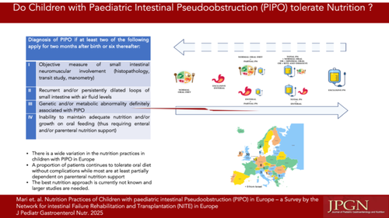](https://onlinelibrary.wiley.com/cms/asset/14f95692-5f22-43d1-81d6-cc8824db9551/jpn370161-gra-0001-m.jpg)

**CONFLICT OF INTEREST STATEMENT**

The authors declare no conflicts of interest.