Link: <https://onlinelibrary.wiley.com/doi/10.1002/jpn3.70156>

[](https://onlinelibrary.wiley.com/journal/15364801)

REVIEW ARTICLE

**Small intestinal bacterial overgrowth in children: An expert review by the ESPGHAN Gastroenterology Committee**

[Puoti Maria Giovanna](https://onlinelibrary.wiley.com/authored-by/Maria+Giovanna/Puoti), [Assa Amit](https://onlinelibrary.wiley.com/authored-by/Amit/Assa), [Benninga Marc A](https://onlinelibrary.wiley.com/authored-by/Marc+A/Benninga), [Broekaert Ilse](https://onlinelibrary.wiley.com/authored-by/Ilse/Broekaert), [Dolinsek Jenej](https://onlinelibrary.wiley.com/authored-by/Jenej/Dolinsek), [Homan Matjaž](https://onlinelibrary.wiley.com/authored-by/Matja%C5%BE/Homan), [Martín-deCarpi Javier](https://onlinelibrary.wiley.com/authored-by/Javier/Mart%C3%ADn%E2%80%90deCarpi), [Mas Emmanuel](https://onlinelibrary.wiley.com/authored-by/Emmanuel/Mas), [Miele Erasmo](https://onlinelibrary.wiley.com/authored-by/Erasmo/Miele), [Misak Zrinjka](https://onlinelibrary.wiley.com/authored-by/Zrinjka/Misak)[**… See all authors**](https://onlinelibrary.wiley.com/doi/10.1002/jpn3.70156)

First published: 29 July 2025

[**https://doi.org/10.1002/jpn3.70156**](https://doi.org/10.1002/jpn3.70156)

**Disclaimer**: Although this paper is produced by the ESPGHAN Gastroenterology Committee it does not necessarily represent ESPGHAN policy and is not endorsed by ESPGHAN.

[**Read the full text**](https://onlinelibrary.wiley.com/doi/full/10.1002/jpn3.70156)

**Abstract**

The aim of this review is to summarize the prevalence, etiology, pathogenesis, diagnosis, and treatments currently available for small intestinal bacterial overgrowth (SIBO) in children. SIBO is a clinical entity characterized by the presence of an excessive number of bacteria in the small bowel leading to several nonspecific gastrointestinal symptoms due to malabsorption and malnutrition, such as bloating, flatulence, belching, diarrhea, abdominal pain, nausea, steatorrhea, fatigue and stunted growth. Initially thought to develop specifically in the context of abnormal or postsurgical gastrointestinal anatomy, it has then been recognized that it can be associated with other nonsurgical conditions, such as gastrointestinal dysmotility, disorders of gut–brain interactions and chronic use of drugs. The uncertainty regarding the exact cut-off of excessive number of bacteria in the small bowel has led to the absence of a universally accepted definition of SIBO making well-designed research to assess the best diagnostic and therapeutic approaches challenging. Current available diagnostic tools includes duodenal/jejunal aspirate with culture and hydrogen breath tests, which all have some limitations and pitfalls that prevent accurate sampling. The treatment goal should be to treat the underlying causes, restore the healthy intestinal microflora, relieve the symptoms and address the associated complications. The use of antibiotics represents the treatment cornerstore. However, they are commonly used despite the scarce published evidence and the absence of agreement on the dose and duration of the treatment. Currently, data on best diagnostic and therapeutic strategies in children remain lacking. Novel diagnostic approaches for SIBO are emerging and may facilitate further research.

**Graphical Abstract**

[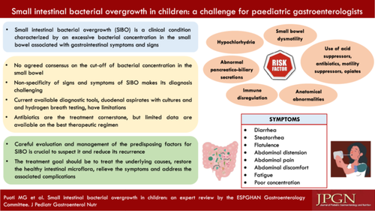](https://onlinelibrary.wiley.com/cms/asset/9b680766-0b64-4879-abe4-451ce985a731/jpn370156-gra-0001-m.jpg)

**CONFLICT OF INTEREST STATEMENT**

The authors declare no conflicts of interest.