Link: <https://onlinelibrary.wiley.com/doi/10.1002/jpn3.70196>

[](https://onlinelibrary.wiley.com/journal/15364801)

ORIGINAL ARTICLE

**Coexistence of hepatitis B e antigen and antibody during antiviral treatment predicts better clinical outcomes in children**

[Yingping Gu](https://onlinelibrary.wiley.com/authored-by/Gu/Yingping), [Wenxian Ouyang](https://onlinelibrary.wiley.com/authored-by/Ouyang/Wenxian), [Shuangjie Li](https://onlinelibrary.wiley.com/authored-by/Li/Shuangjie), [Zhenzhen Yao](https://onlinelibrary.wiley.com/authored-by/Yao/Zhenzhen), [Ling Ye](https://onlinelibrary.wiley.com/authored-by/Ye/Ling), [Meng Yang](https://onlinelibrary.wiley.com/authored-by/Yang/Meng), [Sisi Li](https://onlinelibrary.wiley.com/authored-by/Li/Sisi), [Songxu Peng](https://onlinelibrary.wiley.com/authored-by/Peng/Songxu)

First published: 17 August 2025

[**https://doi.org/10.1002/jpn3.70196**](https://doi.org/10.1002/jpn3.70196)

[**Read the full text**](https://onlinelibrary.wiley.com/doi/full/10.1002/jpn3.70196)

**Abstract**

Objectives

The coexistence of hepatitis B e antigen (HBeAg) and hepatitis B e antibody (HBeAb) during antiviral therapy is considered atypical in patients with chronic hepatitis B (CHB), and its clinical implications remain inadequately understood, particularly in pediatric patients. This study aimed to investigate the clinical characteristics of this coexistence pattern and its impact on the outcomes of combined antiviral therapy in children with CHB.

Methods

A total of 254 treatment-naïve children diagnosed with HBeAg-positive CHB were retrospectively enrolled. All patients received combination therapy with entecavir and interferon-alpha/pegylated-interferon-alpha. Participants were categorized into a coexistence group and a control group based on whether HBeAg and HBeAb coexisted during treatment period. Clinical characteristics and treatment outcomes were compared, and Cox regression analysis was used to evaluate factors influencing the coexistence pattern and its association with antiviral responses.

Results

The incidence of HBeAg and HBeAb coexistence during antiviral therapy was 35.43% (90/254). This pattern was associated with the higher HBV DNA levels (hazard ratio [HR] = 1.25, *p* = 0.009) at baseline. Notably, children in the coexistence group demonstrated a greater likelihood of achieving HBsAg loss (HR = 2.58, *p* < 0.001), HBeAg loss (HR = 2.23, *p* < 0.001) and HBV-DNA undetectability (HR = 1.42, *p* = 0.034).

Conclusions

The HBeAg/HBeAb coexistence pattern is relatively common during antiviral therapy in children and is associated with significantly improved treatment outcomes. These findings highlight the importance of monitoring HBeAg/HBeAb dynamics and continuing treatment during this critical phase.

**Graphical Abstract**

[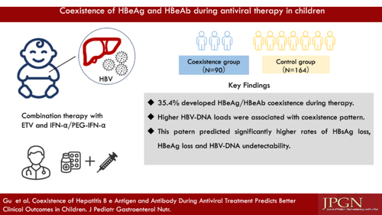](https://onlinelibrary.wiley.com/cms/asset/3336cfd4-5150-4542-8965-9997f24b3c4b/jpn370196-gra-0001-m.jpg)

**CONFLICT OF INTEREST STATEMENT**

The authors declare no conflicts of interest.