Link: <https://onlinelibrary.wiley.com/doi/10.1002/jpn3.70205>

[Journal of Pediatric Gastroenterology and Nutrition](https://onlinelibrary.wiley.com/journal/15364801)

[](https://onlinelibrary.wiley.com/journal/15364801)

ORIGINAL ARTICLE

**Variability in stool symptoms in youth with abdominal pain-associated disorders of gut–brain interaction**

[Jason Lach](https://onlinelibrary.wiley.com/authored-by/Lach/Jason), [Jennifer M. Colombo](https://onlinelibrary.wiley.com/authored-by/Colombo/Jennifer+M.), [Jennifer V. Schurman](https://onlinelibrary.wiley.com/authored-by/Schurman/Jennifer+V.), [Craig A. Friesen](https://onlinelibrary.wiley.com/authored-by/Friesen/Craig+A.)

First published: 01 September 2025

[**https://doi.org/10.1002/jpn3.70205**](https://doi.org/10.1002/jpn3.70205)

[**Read the full text**](https://onlinelibrary.wiley.com/doi/full/10.1002/jpn3.70205)

**Abstract**

Objective

Irritable bowel syndrome (IBS) is divided into subcategories recognizing differences in stool frequency and form. The third IBS symptom, a change in pain with stools may also introduce heterogeneity and has not been well described in youth with IBS. The current study was undertaken to assess changes in pain with stooling and the presence of nocturnal stools.

Methods

We assessed 300 patients with a diagnosis of abdominal pain-associated disorder of gut–brain interaction (AP-DGBI). Patients were queried regarding Rome IV AP-DGBI criteria along with characterizing changes in pain with stooling (direction, frequency and degree of change) and the occurrence of nocturnal stools. Additionally, we reviewed the findings from 140 patients who underwent colonoscopies.

Results

Regarding pain with stooling, 59% reported no difference, 26.7% reported decreased pain, and 14.3% reported increased pain. There was significant variability in both frequency and degree of change in pain. Increased pain with stools was associated with a change in stool frequency and form. Nocturnal stools were reported in 19.7% of participants. Colonic mucosal inflammation or more often low-grade mucosal eosinophilia was found more frequently in those reporting nocturnal stools (33% vs. 15.4%; *p* = 0.02).

Conclusions

We found significant heterogeneity regarding changes in pain with bowel movements in IBS including the direction of change, degree of change and frequency of change. Increase in pain with stools appears to be a better fit with the other cardinal symptoms of IBS than is decreased pain with stooling. Nocturnal stooling was not uncommon in AP-DGBI and may be associated with low-grade eosinophilia in some patients.

**Graphical Abstract**

[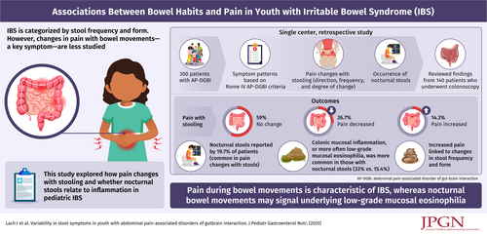](https://onlinelibrary.wiley.com/cms/asset/e467df55-1fdb-4030-ab88-40d008d12fe8/jpn370205-gra-0001-m.jpg)

**CONFLICT OF INTEREST STATEMENT**

The authors declare no conflict of interest.